COA ASSIGNMENT No. 5
Aaditya Yuvaraj Hande
Div/Batch: A/A1
Roll No: 17
PRN: 202401040028

Topic: Multiplication

Result:
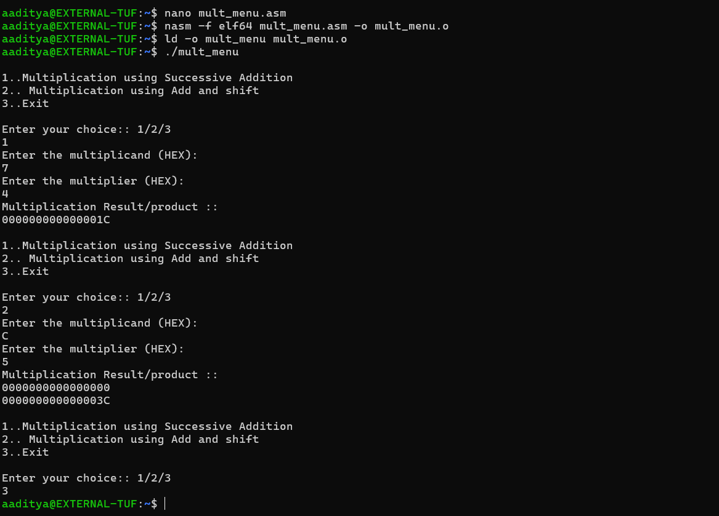
Code:
; mult_menu.asm - fixed syntax for NASM x86-64 (WSL)
; Menu: multiplication using successive addition or add-and-shift
; Uses raw syscalls for I/O

%macro write 2
mov rax, 1
mov rdi, 1
mov rsi, %1
mov rdx, %2
syscall
%endmacro

%macro read 2
mov rax, 0
mov rdi, 0
mov rsi, %1
mov rdx, %2
syscall
%endmacro

section .data
msg db "1..Multiplication using Successive Addition ",10
db "2.. Multiplication using Add and shift ",10
db "3..Exit",10
msg_len equ $-msg

choice_msg db "Enter your choice:: 1/2/3",10
ch_len equ $-choice_msg

msg1 db "Enter the multiplicand (HEX):",10
msg1_len equ $-msg1

msg2 db "Enter the multiplier (HEX):",10
msg2_len equ $-msg2

msg3 db "Multiplication Result/product ::",10
msg3_len equ $-msg3

msg_space db " ",10
msg_space_len equ $-msg_space

section .bss
num resb 17
choice resb 2
buff resb 16
no resq 1
ccnt resq 1
no1 resq 1
no2 resq 1
A resq 1
B resq 1
Q resq 1
n resq 1

section .text
global _start
_start:
main_menu: ; label
write msg_space, msg_space_len
write msg, msg_len
write msg_space, msg_space_len
write choice_msg, ch_len

read choice, 2
cmp byte [choice], '1'
je op1
cmp byte [choice], '2'
je op2
cmp byte [choice], '3'
je op3
jmp main_menu

; -------------------------------------------
; OPTION 1 : SUCCESSIVE ADDITION
; -------------------------------------------
op1:
write msg1, msg1_len
read num, 17
dec rax
mov qword [ccnt], rax
call accept ; accept -> RAX = parsed value
mov qword [no1], rax

write msg2, msg2_len
read num, 17
dec rax
mov qword [ccnt], rax
call accept
mov qword [no2], rax

xor rbx, rbx ; rbx = 0 (result)

l1:
add rbx, qword [no1]
dec qword [no2] ; decrement multiplier by 1
cmp qword [no2], 0
jne l1

write msg3, msg3_len
mov rax, rbx ; place result in RAX for disp to use if needed
call disp
jmp main_menu

; -------------------------------------------
; OPTION 2 : ADD–AND–SHIFT MULTIPLICATION
; -------------------------------------------
op2:
write msg1, msg1_len
read num, 17
dec rax
mov qword [ccnt], rax
call accept
mov qword [B], rax

write msg2, msg2_len
read num, 17
dec rax
mov qword [ccnt], rax
call accept
mov qword [Q], rax ; Q is multiplier

mov qword [A], 0 ; Accumulator = 0
mov qword [n], 64 ; counter

above:
mov rax, qword [Q] ; multiplier value
and rax, 1 ; get LSB (q0)
cmp rax, 1
jne shift_no_add

mov rax, qword [A]
add rax, qword [B] ; A = A + B
mov qword [A], rax

shift_no_add:
mov rax, qword [A]
mov rbx, qword [Q]
shr rbx, 1

mov rdx, rax
and rdx, 1 ; get LSB of A
cmp rdx, 1
jne do_shift

; rotate right 1 of 1 into MSB position and or into Q (original logic)
mov rdx, 1
ror rdx, 1
or rbx, rdx

do_shift:
mov rax, qword [A]
shr rax, 1
mov qword [A], rax
mov qword [Q], rbx

dec qword [n]
jnz above

write msg3, msg3_len
mov rax, qword [A]
call disp
mov rax, qword [Q]
call disp
jmp main_menu

; -------------------------------------------
; OPTION 3 : EXIT
; -------------------------------------------
op3:
mov rax, 60
xor rdi, rdi
syscall

; -------------------------------------------
; accept : parse HEX string from 'num' into RAX
; returns value in RAX
; -------------------------------------------
accept:
xor rbx, rbx
mov rsi, num

up1:
shl rbx, 4
mov dl, byte [rsi]
cmp dl, '9'
jbe ok_digit
sub dl, 7
ok_digit:
sub dl, '0'
movzx rdx, dl
add rbx, rdx
inc rsi
dec qword [ccnt]
jnz up1
mov rax, rbx
ret

; -------------------------------------------
; disp : print RAX (or RBX) in HEX as 16 hex digits into buff
; (keeps your original hex-style display routine)
; -------------------------------------------
disp:
; choose value in rax (we use RAX)
mov rbx, rax
mov rsi, buff
mov rcx, 16
up2:
rol rbx, 4
mov dl, bl
and dl, 0Fh
cmp dl, 09h
jbe digit_is_num
add dl, 7
digit_is_num:
add dl, '0'
mov [rsi], dl
inc rsi
dec rcx
jnz up2

write buff, 16
write msg_space, msg_space_len
ret

